Esra Kaya

200315083

Computer Engineering

My E Commerce Project

I wanted to create an e-commerce site in this code. First I created a package called ECommerce.

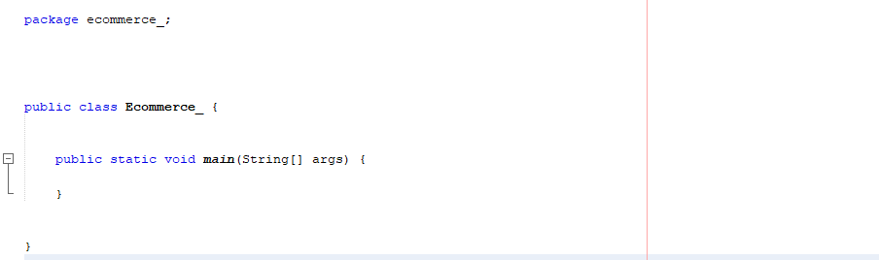

And I created a java class called User under this package. This class keeps the user's name, last name, email, date of birth, password, home and work address, number of products they order, favorite products, and credit card information.

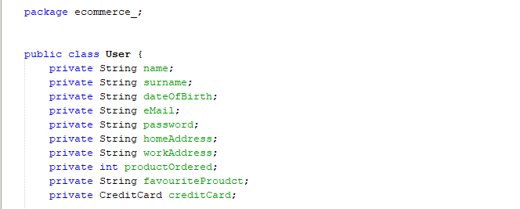

Then, i created a default consstructor for User.

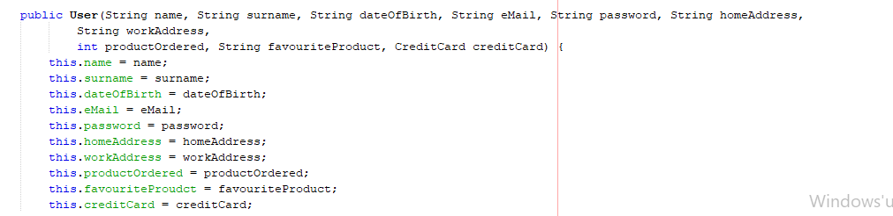

I wrote the getter methods to access the variables that we defined private later, and the setter methods to change them later. For example:

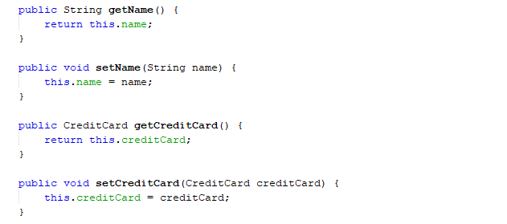

I have defined a method called puchasing to increase the number of products ordered with each purchase.

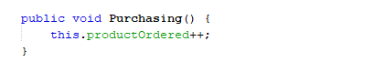

And I have written a method that shows the user's favorite products.

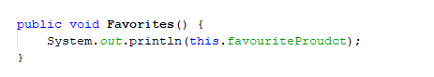

I have written a method that allows the productOrdered variable to increase according to how many times the user receives from a product.

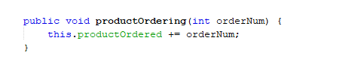

Then, I created a class that contains the name, color, category, inventory information, weight and description of the products.

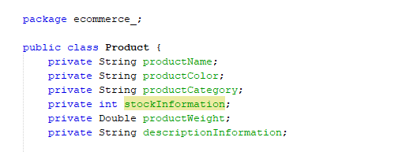

Then I created a default constructor that contains them all.

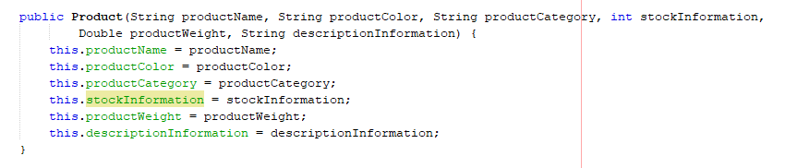

And again I wrote the getter and setter methods for each of them. For instance;

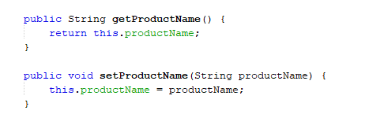

I have written a method that reduces the product inventory information by that number after ordering the products. In addition, this method gives the user a warning if the number of ordered products exceeds the number of stocks.

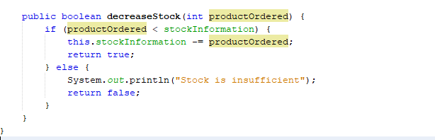

Then I created a credit card class. This class contains the credit card number, its user, security code and expiration date.

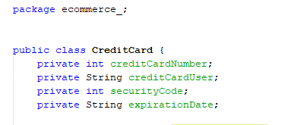

It’s default constructor:

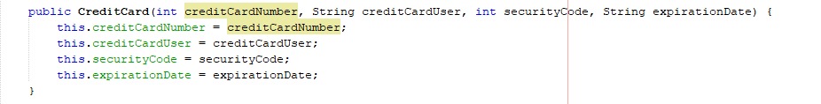

And example of getter and setter:

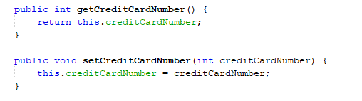

Finally, I created an Order class that contains the user who ordered, the product that was ordered, the credit card that was used, and the number of orders.

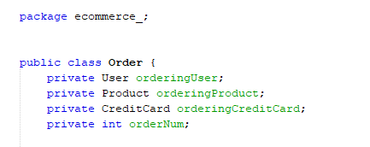

It’s default constructor:

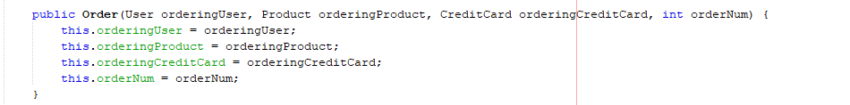

And example of getter and setter;

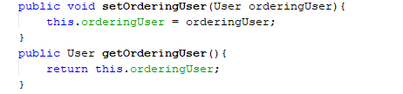

And in this class, I created an ordering method that accesses the ordered product and inventory information.

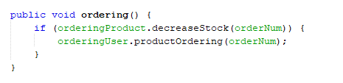

Finally, I wrote my main method in the Ecommerce class, which is our test class. Here I have created three sample product objects, three credit card objects, and three user objects.

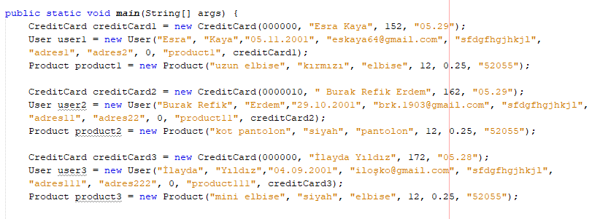

Then, thanks to Scanner, I printed the user's name on the screen and asked the user to select the product and how many pieces he wanted.

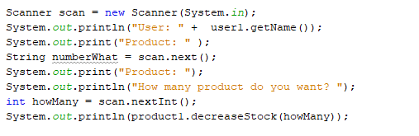

It’s output is here;

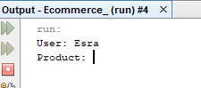

Then i enter information;

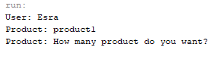

Remember: product1’s stock information was 12.

If my number is smaller than stock, it say me true;

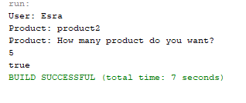

But if my number is bigger than stock, it say me “false, Stock is insufficient”

